

Geospatial Analysis
CUSUM RAP
User manual

Developer: CEMIC
Authors: Fernando Poletta, Juan Gili, Maximiliano Giordano
Version 2.0

Intended Users, Administration, and Adaptation to Other Contexts
This application is intended to support public health surveillance and response activities, and may be used by healthcare professionals, public health officers and other personnel responsible for reporting, reviewing, managing or analysing epidemiological information. Depending on the implementation context, the administration, configuration and maintenance of the application may also be carried out by municipal or regional health secretariats, by public health authorities, or by local National Statistical Office (NSO) teams.
The examples, screenshots and simulated datasets included in this document are based on the administrative and data structure used by the National Institute of Statistics and Censuses (INDEC) in Argentina, and are provided as a reference implementation. The application can nevertheless be adapted for use in other countries and institutional settings, regardless of whether a given country has an established national epidemiological surveillance system in place. Detailed guidance on adaptation, configuration and implementation in other national contexts is provided throughout this Technical Documentation, as well as in the additional technical, support and version-control materials available in the project's GitHub repository.
The National Statistical Office (NSO), or an equivalent national technical authority, may support users by providing guidance on how to interpret the outputs of this tool. This support may include advice on data quality, on geographic standardisation and on the appropriate use of spatial indicators within national public health and statistical frameworks.

ANALYSIS FOR ACTION
CUSUM-RAP
User Manual
Early-warning analysis for weekly case counts

Documentation revision | June 2026
Language | English
Status | Aligned with the supplied current application source

Contents

1. Purpose and scope 3
2. Open the app and load data 3
3. Input data 5
4. Configure the analysis 6
5. Review the outputs 7
6. Interpretation guide 12
7. Downloads and reproducibility 12
8. Troubleshooting 13
9. Glossary 13
Summary 14

1. Purpose and scope

The CUSUM-RAP tool applies a one-sided upper cumulative sum procedure to weekly case counts. In practice, this means that the tool monitors the reported number of cases in each area week by week, and accumulates the evidence whenever those counts rise above the level that would normally be expected. It is designed to highlight sustained increases above an expected baseline for each selected analysis unit**, so that emerging problems can be identified early.**
This manual is intended for analysts, epidemiologists, surveillance officers and other users who need to run the tool and review the outputs. Technical teams who need to configure countries, file structures or deployment settings should instead use the separate developer and administrator guide.
National Statistical Office teams, or equivalent local technical teams, may support users by advising on data quality, territorial coding and the appropriate interpretation of the outputs within national statistical and public health frameworks.
The main features of the tool can be summarised as follows:
- The analysis is performed separately for every selected geographic unit**, so that each area is assessed against its own expected baseline.**
- The current workflow is count-based**, meaning that it works directly with the number of reported cases.**
- Population figures may be uploaded, but they are not required for the standard CUSUM calculation.
- The detection period controls the recent weekly window used for the analysis, whereas the prepared-data coverage rules may require a longer underlying history.
Interpretation. A CUSUM alarm is an early-warning signal, not a diagnosis, a causal conclusion or a confirmation of an outbreak. Before acting on an alarm, review the data quality, any reporting changes, the denominators, the local context and other surveillance evidence.

2. Open the app and load data
Start the application and open the Files menu. From there, upload one or more CSV files from your computer. The tool creates an in-memory session for the uploaded files, which means that it works on a temporary copy and does not modify the original source files on your computer.
- Open the app.
- Go to Files in the top menu bar.
- Select Upload raw data.
- Choose one or more CSV files.
- If duplicate location and week records are detected, choose an overlap rule before running the analysis.
The standard input comes from API-POP. Users may also, however, upload their own prepared CSV files, provided that they follow the required weekly structure and naming rules described below and in the developer guide.
When more than one file is active, some locations and weeks may appear in more than one file. In that case, the tool asks how to resolve the duplicated records before running the analysis.

Option | Effect
Keep newest file information | For an overlapping combination of location and week, the tool retains the record from the most recently uploaded active file.
Keep oldest file information | The tool retains the record from the earliest uploaded active file.
Add together (sum) | The overlapping case counts are added together. Use this option only when the records represent complementary data, rather than duplicate exports of the same figures.

Data safety. File management and overlap resolution affect only the current analysis session. The original uploaded files are never modified.

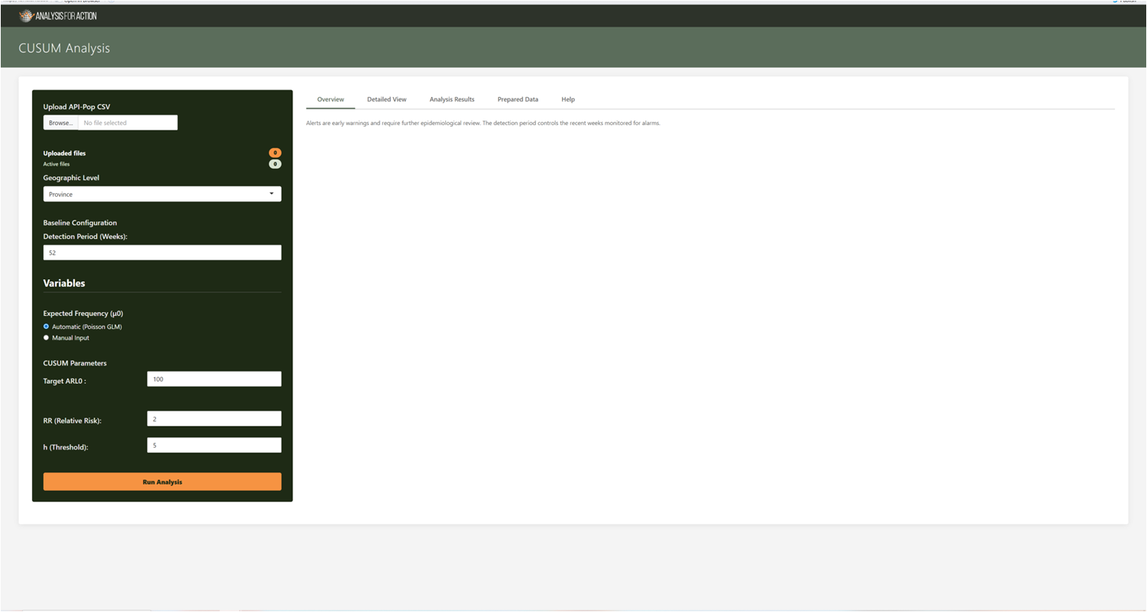
Figure 1. Load data

3. Input data
Upload one or more CSV files. Both comma-delimited and semicolon-delimited files are supported. Each row should represent a single geographic unit in a single epidemiological week.

Internal column | Required | Meaning | Accepted aliases or examples
year | Yes | The epidemiological year. | year, anio, año, epiyear
week | Yes | The epidemiological week, normally 1 to 53. | week, semana, epiweek, se
country | Recommended | The country or national unit. | Argentina
level1 | Depends on selected level | The first administrative level. | province, region, Level1
level2 | Depends on selected level | The second administrative level. | department, district, LAD, Level2
level3 / level4 | Depends on selected level | More detailed administrative levels. | fraction, MSOA, Level3
n_cases | Yes | The observed weekly case or event count. | n_cases, cases, case_count, count, n
population | Optional | Not required by the current count-based CUSUM calculation. | population, pop, denominator

Multiple uploaded files
All newly uploaded files are active by default. Use Manage files to include or exclude individual files, to remove inactive files or to clear the session entirely.

4. Configure the analysis
Once the files are loaded, use the left-hand sidebar to set the analysis options, and then select Run Analysis to start the calculation.

Control | Current behaviour
Geographic level | Defines the administrative level at which the data are grouped in order to build the independent analysis units. The CUSUM procedure is then run separately for each unit at this level.
Locations | Restricts the analysis to a chosen subset of units. If no location is selected, the tool includes every unit available at the chosen geographic level.
Detection period (weeks) | Sets the recent weekly window that the analysis examines for alarms. The interface accepts values from 4 to 260 weeks, with a default of 52. Regardless of the value chosen, the coverage validation currently requires at least the larger of this value and 52 prepared weeks of data.
Automatic expected frequency | Estimates the expected weekly count separately for each analysis unit, using the current Poisson-model workflow. Choose this option when you want the tool to derive the baseline from the data themselves.
Manual expected frequency (mu0) | Uses a fixed expected weekly count that you enter yourself, instead of estimating it from the data. The value must be a case count per unit and per week, not a prevalence rate.
Target ARL0 | Sets the target Average Run Length under the in-control state: that is, the expected number of weeks before a false alarm occurs when there is no real increase in cases. A higher target makes false alarms rarer, at the cost of slower detection.
Relative risk (RR) | Specifies the size of the increase that the CUSUM is intended to detect. Together with the expected count, it determines the reference value k.
Calculated k | The reference value used by the procedure, shown by the app for transparency. It is calculated automatically from the relative risk and the expected count, and is not entered directly.
h threshold | The decision threshold that the cumulative statistic must reach in order to raise an alarm. A larger value generally produces fewer alarms and slower detection.

Coverage validation. Missing combinations of location and week can be filled with zero cases in the prepared dataset, but the tool checks the observed coverage first. It stops when the available time span is too short, or when too large a proportion of the series would have to be inferred.

5. Review the outputs

Once the analysis is complete, review the outputs through the main tabs in the application.
Overview
The Overview heatmap summarises the alarms across all locations and recent weeks, so that you can see at a glance where and when the CUSUM crossed its threshold. The detection period controls the range of weeks displayed for alarm monitoring.

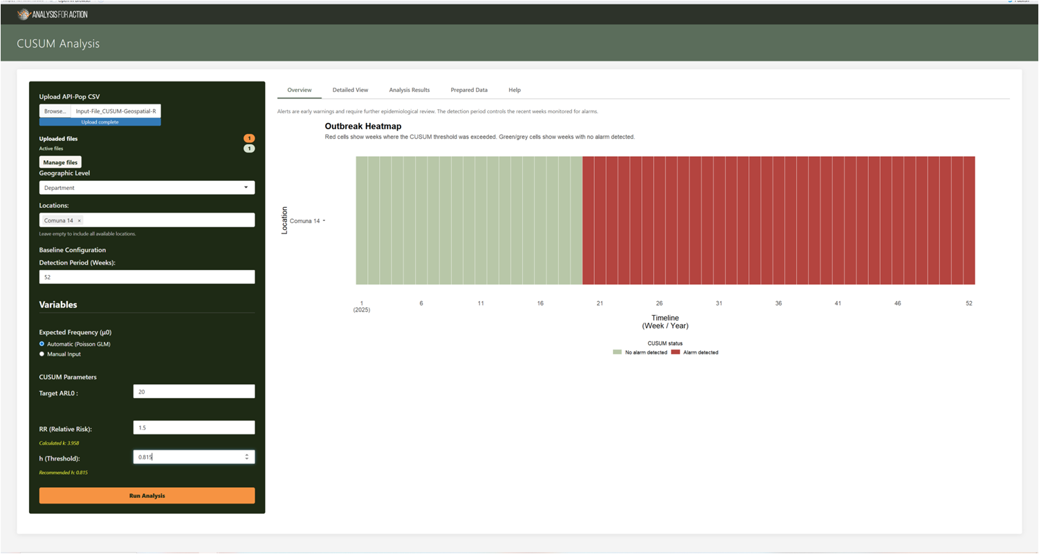
Figure 2. Outputs overview.

Detailed View
Select a single location using the hierarchical selectors. The summary card then reports the details of that location: the current administrative selection, the analysis level, the number of weeks analysed, the date range, the population where available, whether any alarms occurred and the most recent alarm week.
- Observed series plot: compares the observed weekly values with the expected baseline.
- CUSUM process plot: displays the cumulative statistic and the threshold over time.
- The Download Bar Plot and Download Trends buttons export the selected plots once results are available.

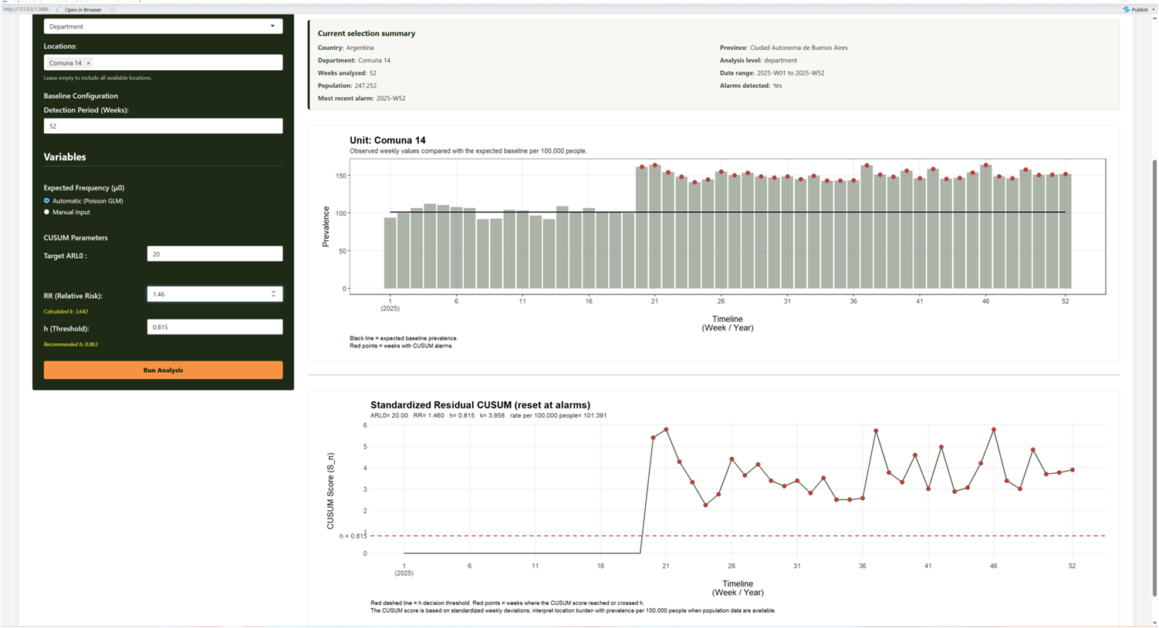
Figure 3. Detailed View.

Analysis results
The Unit-level reference table reports the expected weekly cases and the expected rates, once per unit. The Weekly results table contains the full time series, including the observed values, the CUSUM statistic, the alarm state and the associated parameters. Use Search by to filter the table by a chosen column.
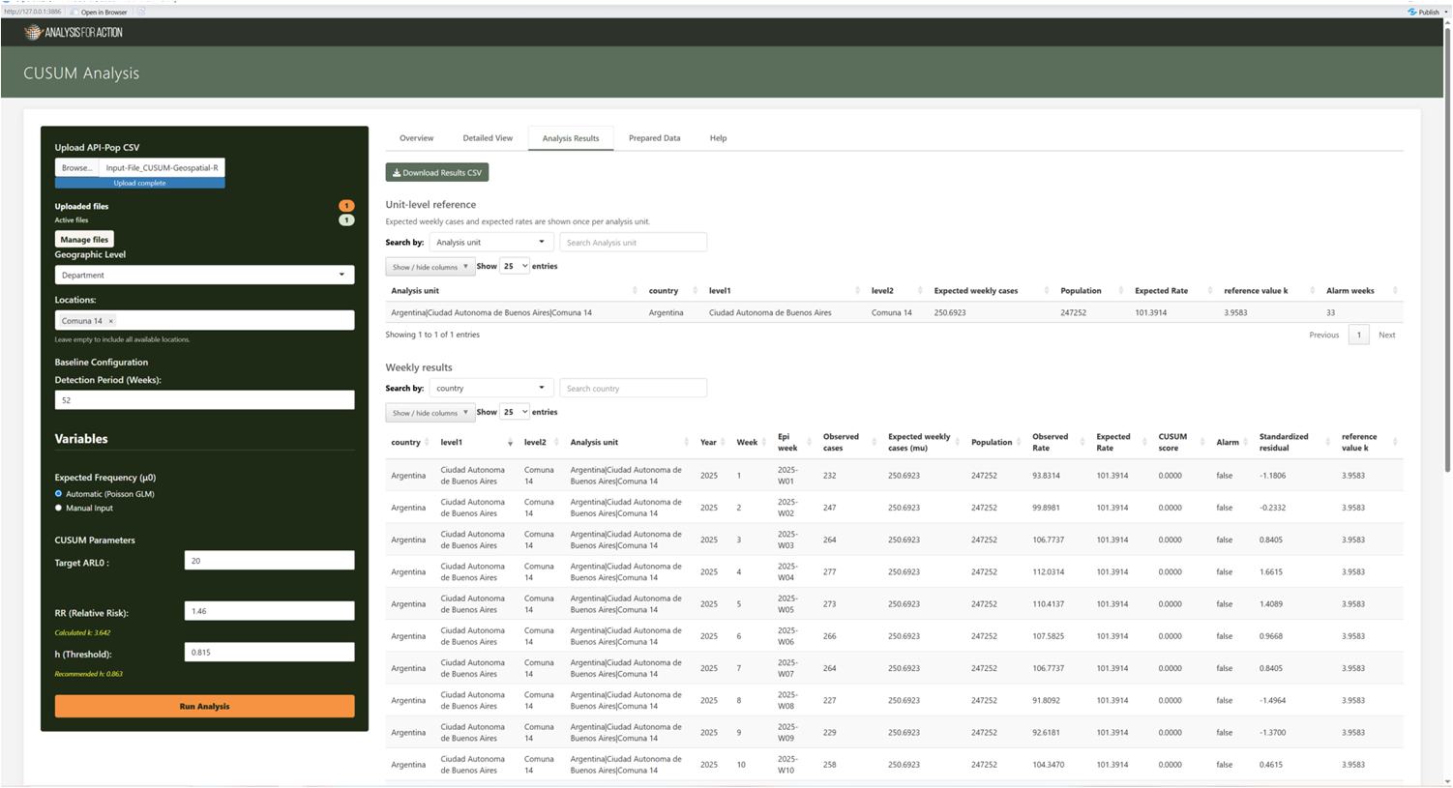
Figure 3. Analysis

Prepared Data
This tab shows the cleaned, aggregated, overlap-resolved and gap-completed dataset that is actually used in the analysis. It includes a coverage assessment, a preparation log, summary information, the number of added rows, a filterable table and a CSV download.

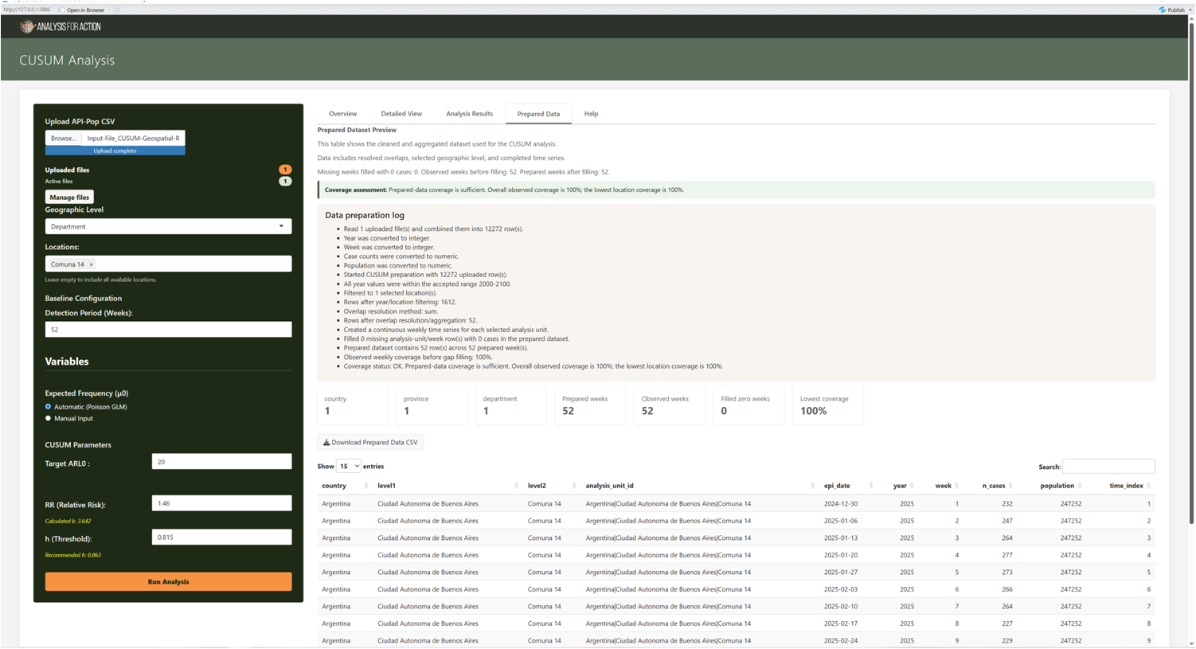

Figure 4. Prepared Data

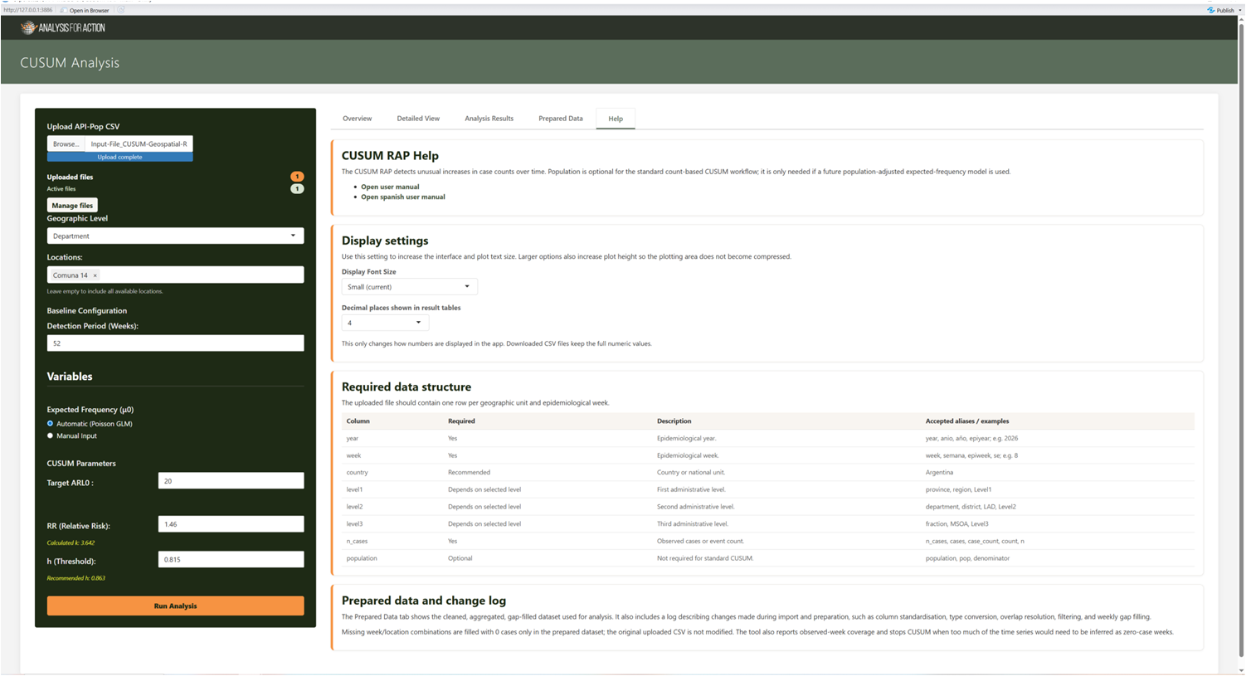
Display settings. The Help tab can increase interface and plot font size and change the number of decimal places shown in tables. These settings do not round downloaded CSV values.

Figure 5. Display Settings

6. Interpretation guide
For each detection week, the tool standardises the difference between the observed and the expected counts, subtracts the reference value k, and adds any positive evidence to a one-sided cumulative statistic. The statistic is never allowed to fall below zero. An alarm is marked when the statistic reaches or exceeds the threshold h. After an alarm, the current application resets the running statistic, while preserving the peak value reached in that week.

Pattern | Suggested interpretation
Observed values repeatedly above expected | The CUSUM tends to accumulate over successive weeks and may eventually reach h, raising an alarm.
Observed values close to or below expected | The CUSUM tends to remain low or to return to zero, without raising an alarm.
Single isolated high week | This may or may not raise an alarm, depending on its magnitude and on the evidence already accumulated.
Many zero-filled weeks | Review the coverage warnings and confirm that the missing reports genuinely represent zero cases, rather than absent data.
Alarm in several neighbouring units | Investigate shared reporting changes, common exposures, population movement and broader epidemiological evidence.

7. Downloads and reproducibility

Download | Contents
Download Bar Plot | The observed and expected weekly series for the location currently shown in the Detailed View.
Download Trends | The CUSUM process plot for the location currently shown in the Detailed View.
Download Results CSV | The complete analysis output for every unit and week analysed.
Download Prepared Data CSV | The cleaned and aggregated input dataset used by the analysis.
On-screen table filters and decimal-place settings affect only the view. The downloaded files retain the underlying rows and the full numeric precision produced by the analysis.

8. Troubleshooting
Problem or message | What to check
Missing required columns | Confirm that the file contains year, week and n_cases, or an accepted alias for each, together with the column required for the selected geographic level.
No locations available | The chosen geographic level may not exist in the active data, or its values may be blank.
Insufficient prepared weeks | Upload a longer weekly history, or reduce the detection period, bearing in mind that the current configured minimum is 52 prepared weeks.
Low observed coverage | Confirm whether the absent weeks represent true zero cases. If they correspond to missing reports, upload a more complete series.
Unexpectedly large counts after combining files | Review the active files and the selected overlap method, particularly Add together (sum).
Automatic baseline appears implausible | Inspect the selected units and their history, then compare the result with an appropriate manual expected weekly count.

Escalation package. When reporting a problem, include the active file names, selected country and level, location selection, parameter values, the preparation log and the exact error text. Do not send identifiable or restricted data through an unapproved channel.

9. Glossary

Term | Meaning
mu0 / expected frequency | The expected weekly case count for an analysis unit, against which observed counts are compared.
k | The reference value that controls how strongly deviations from the expected count contribute to the CUSUM.
h | The decision threshold that the cumulative statistic must reach in order to raise an alarm.
ARL0 | The average run length expected under the no-change condition: that is, the average number of weeks before a false alarm occurs when there is no real increase in cases.
RR | The relative-risk increase that the design is intended to detect.
Prepared week | A weekly row that is present in the dataset after aggregation and optional zero filling.
Observed coverage | The proportion of prepared weeks that originate from observed uploaded records, rather than from inserted zero rows.

Summary
CUSUM-RAP is a configurable application for the early-warning analysis of weekly case counts. It reads prepared weekly data, builds unit-level baselines, applies the configured CUSUM parameters and produces heatmaps, detailed plots, tables and downloadable outputs. This revised manual clarifies the intended audience, the launch steps, the input structure, the interpretation of results and the troubleshooting procedures, so that users can apply the tool more consistently in routine surveillance settings.

